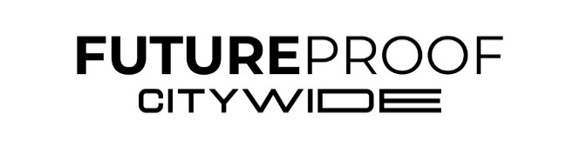
TRADESHOW SERVICES ORDER FORM
Email orders to: cindyk@mpgproductions.com
Email orders by February 13, 2026, to ensure equipment availability and to avoid an expedited charge.
CUSTOMER INFORMATION
Company Name: Booth Number:
Customer Onsite Contact Name:
Conference Name: Future Proof Citywide 2026
Onsite Contact Phone: Start Date: 3/7/2026

DISPLAY AND VIDEO PLAYBACK OPTIONS
EQUIPMENT OPTIONS RATE QTY TOTAL
65” LCD Monitor Package* $1880.00 $
Windows Laptop $350.00 $
Wireless Mouse $50.00 $
Media Player (looping video) $50.00 $
Slide Advancer $25.00 $
Power Strip $25.00 $
Super bright and different-sized monitors. Please email for pricing.

If you require AirPlay, please reach out, as it requires additional gear.
Total Due $
*Package includes HDMI cord, dongle, extension cord, power strip, stand/mount, & labor

